**U8903B firmware upgrade procedures**

The U8903B firmware update file can be obtained from the Keysight U8903B firmware update Web site at [www.keysight.com/find/audioanalyzer_firmware](http://www.keysight.com/find/audioanalyzer_firmware).

Perform the following procedure to update the U8903B firmware.

**1** Save the firmware update files in an external USB flash storage.

**2** Connect the external USB flash storage to the U8903B.

**3** Press on the SYSTEM panel.

**4** From the System menu page, press the **Update** softkey. The Update menu page is displayed as shown in **figure 1-6**.



**Figure 1-6** System > Update menu page

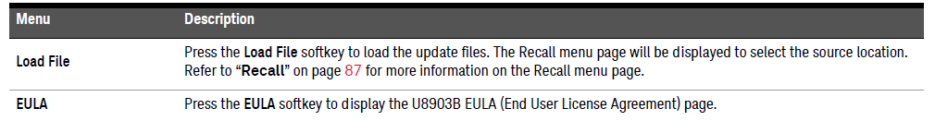

**5** Press the **Load File** softkey and the recall menu page is displayed to enable you to select the source location.

**6** Select the firmware file (xxx.bin) to be updated, and press the **Recall** softkey as shown in **Figure 1-7**.

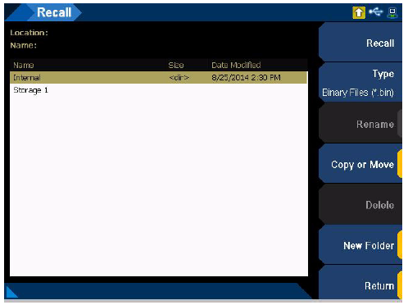

**Table 1-7** System > Update menu page

**Menu Description**

The firmware update process may take 20 minutes to 40 minutes to complete. **DO NOT** power off the U8903B.